Screen shots of this Weather App - June 18, 2016

==================================================

**App started:**

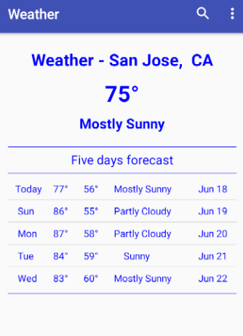

======================================================

**After Search-Icon clicked in App-bar and user typed San Francisco in App-bar**:

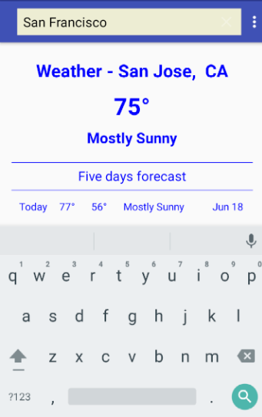

===============================================

**Weather for San Francisco is shown**:

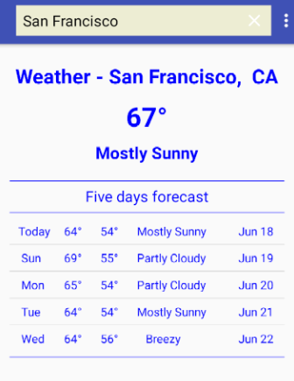

=====================================================

Error handling with bad input city name for weather.

